**Task 01 :**

Write a Query using “As” for extracting specific data from a Table.

**(Query Text)**

Select Name+Father_Name As Full_Name from Computer_Science

**(Query Output)**

**(Query Text)**

Select Name,batch As [Year of Enrollment] from Computer_Science

**(Query Output)**

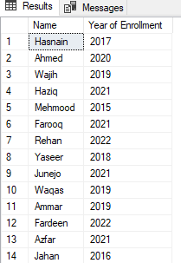

**Task 02 :**

Write a Query using “Update” for Changing specific data from a Table.

**(Query Text)**

Update Computer_Science Set batch = '2022' where id = 22

**(Query Output)**



**(Query Text)**

Update Computer_Science Set Department = 'se',Semester = 6 where id = 12

**(Query Output)**



**Task 03 :**

Write a Query using “Like” for fetching specific data from a Table.

**(Query Text)**

Select * from Computer_Science where Name like 's%'

**(Query Output)**

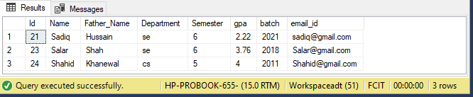

**(Query Text)**

Select * from Computer_Science where Name like '%r'

**(Query Output)**

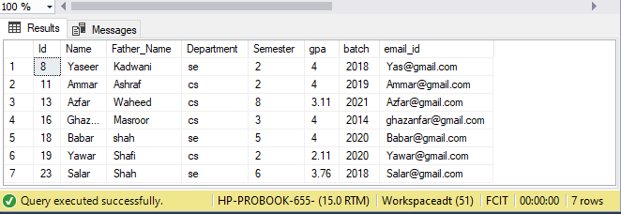

**(Query Text)**

Select * from Computer_Science where Father_Name like '%h%'

**(Query Output)**

**Task 04 :**

Write a Query using “Where” for fetching specific data from a Table.

**(Query Text)**

Select * from Computer_Science where Semester=4

**(Query Output)**

